**TY B.Tech. (CSE) – II [ 2022-23 ]**

**5CS372 : Advanced Database System Lab.**

**Assignment No. 3**

**PRN: 2020BTECS00079**

**Title: Design and implement a web enabled (portal) student MIS**

**(Management Information System) for University Schema**

**Technology Stack: ReactJS/ NodeJS/ MySQL**

**MySQL:**

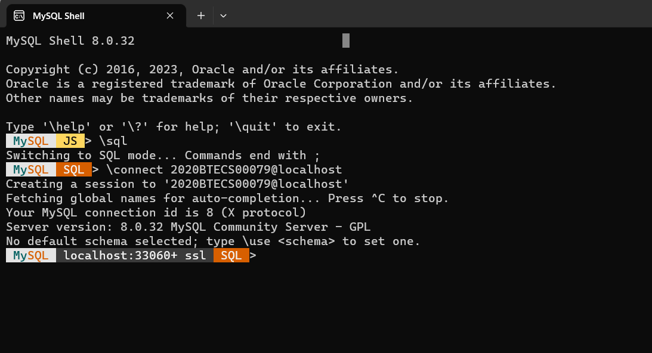

**MySQL WorkBench**

